GODDARD High School

701 E COUNTRY CLUB, ROSWELL, NM 88201

2022 END OF SCHOOL YEAR CHESS EXIBITION
MONDAY, May 16th, 6:00 pm – 8:00 pm

SCHOOL CAFETERIA
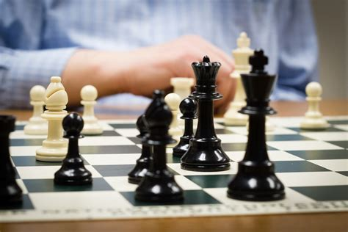
Players of All School Ages Players of All Skills
Roswell School District We are looking to develop
Private Schools Welcome! interest in Scholastic Chess
Elementary in 2023-2024 School Year
Middle
High School

All levels of players welcome but must be familiar with basic rules of chess. QUESTIONS?
No Costs! Contact Larry Dunlap ldunlap@risd.k12.nm.us for signup

Presented By: Mark Austin (Roswell Chess Encounter; USCF Affiliate# A6052431) Email: mark.austin@chess-encounter.com Cell# 949.295.0125

